Student’s name | …………………………………………………….…… | Grade | 3
Subject | Computer | Quiz No. | 1
Quiz No. ( 1 )
Question A: State whether the statements are (True / False).
- Shape outline is used to apply borders to shapes.
- True b. False
- Layout option is used to align a picture with text.
- True b. False
- Change the colour of a speech bubble and rectangle with shape Fill
- True b. False

Question B: Write the correct name of each part.
Check List | Menu Card
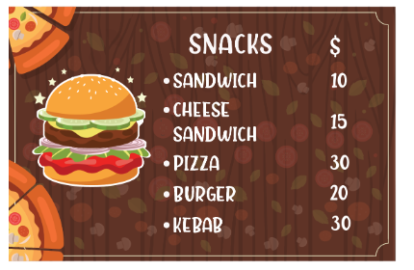
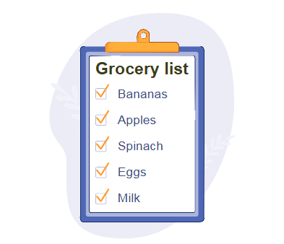
Good Luck

